**INDIA’S AGRICULTURAL CROP PRODUCTION**

**1. INTRODUCTION**

1.1 Overview

1.2 Purpose

**2. PROBLEM DEFINITION & DESIGN THINKING**

2.1 Empathy Map

2.2 Ideation & Brainstorming Map

**3. RESULT**

**4. ADVANTAGES AND DISADVANTAGES**

**5. APPLICATIONS**

**6. CONCLUSION**

**7. FUTURE SCOPE**

**8. APPENDIX**

**INTRODUCTION**

**OVERVIEW :**

This report delves into the captivating realm of India’s agricultural cultivation,

Providing a comprehensive visual exploration of key aspects and trends in the

Agricultural sector. Through the visual representations, readers can gain

Valuable insights into crop production, seasonal variations, regional

Distribution, and overall production trends. These visualizations enable

Intuitive analysis, allowing stakeholders to uncover patterns, identify areas of

Growth or concern, and make data-driven decisions.

By harnessing the power of Tableau, this report not only presents the data in a

Visually appealing manner but also provides an interactive experience for

Readers to explore the intricacies of India’s agricultural cultivation. To Extract

The Insights from the data and put the data in the form of visualizations,

Dashboards and Story we employed Tableau tool.

**PURPOSE :**

By this visualization we can easily find the fluctuations in the India’ s agricultural crop

production in 1997 – 2020 in correspondence with seasons, areas, crop production, major crop,

cultivation and yield. It is easy to visualise the particular crop in different fields by different

methods of visualization.

**PROBLEM DEFINITION & DESIGN THINKING :**

**EMPATHY MAP :**

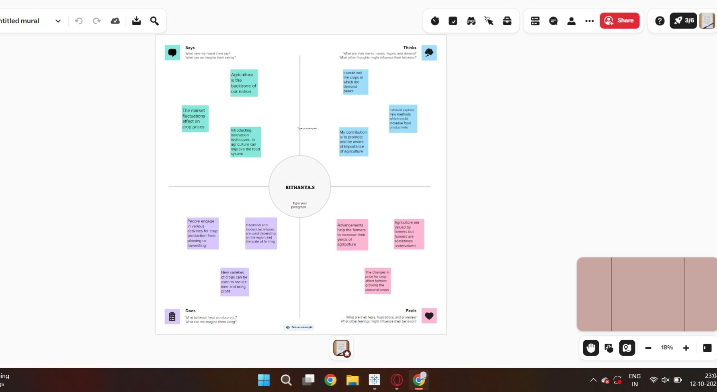

**BRAIN STROMING :**

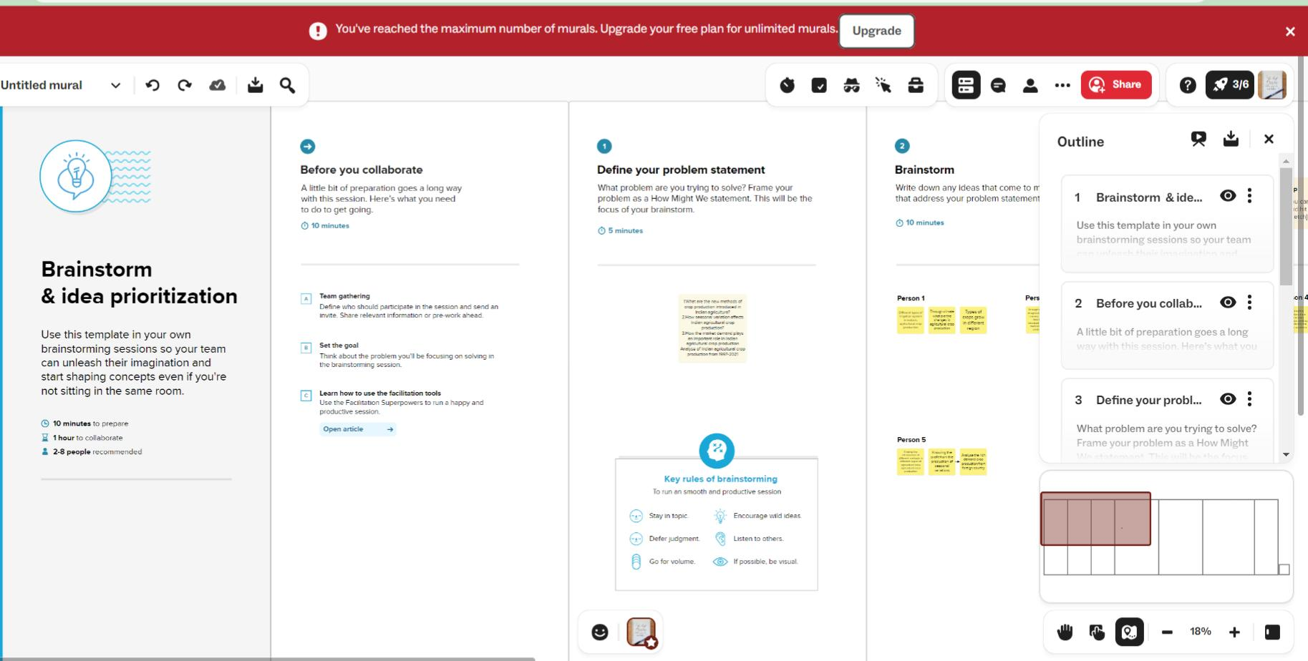

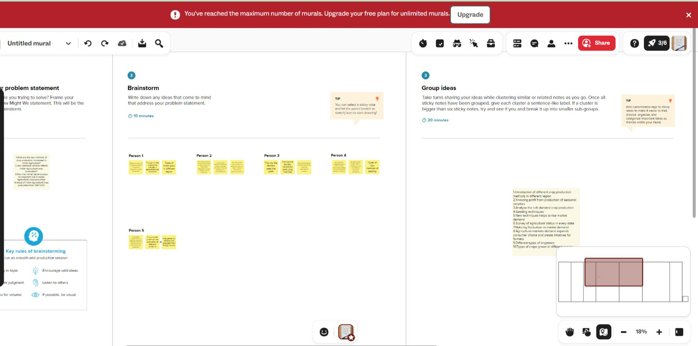

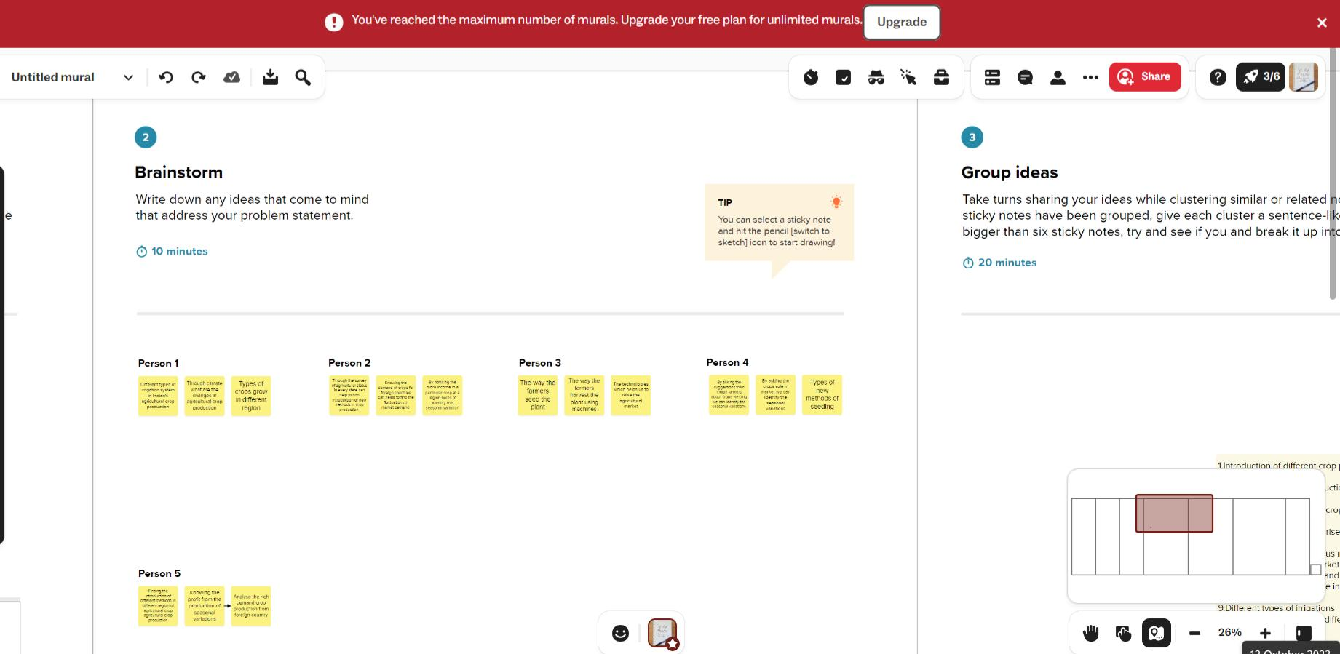

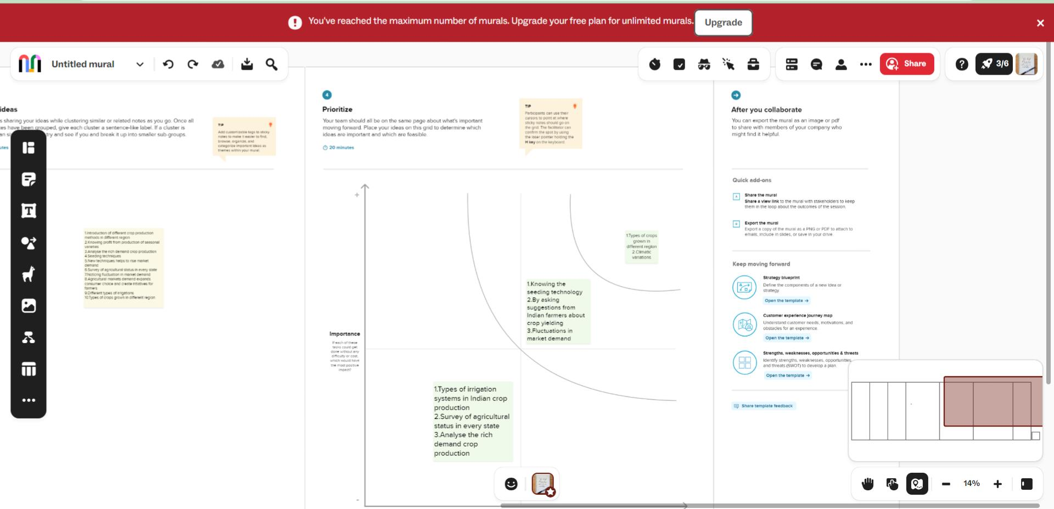

**RESULT :**

India’s agricultural crop production that includes state wise yield, seasons, crops, areas, and production wise is visualized by different graphs and charts.

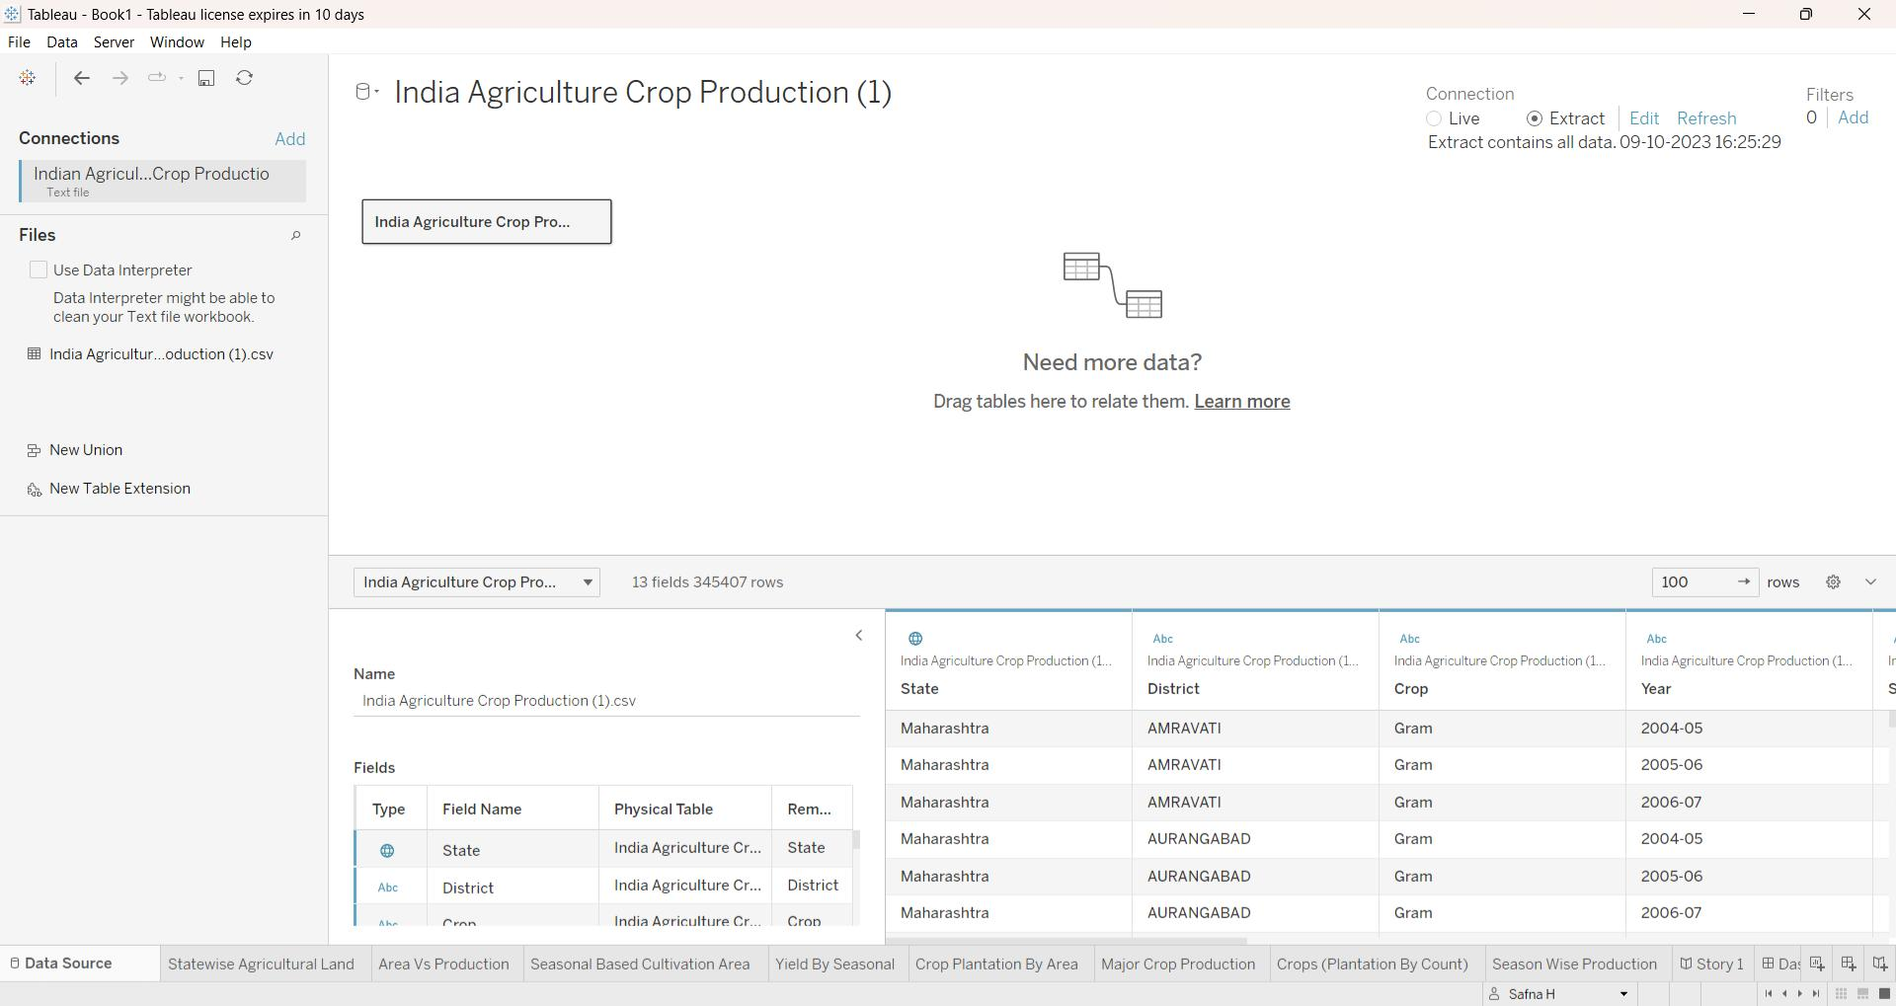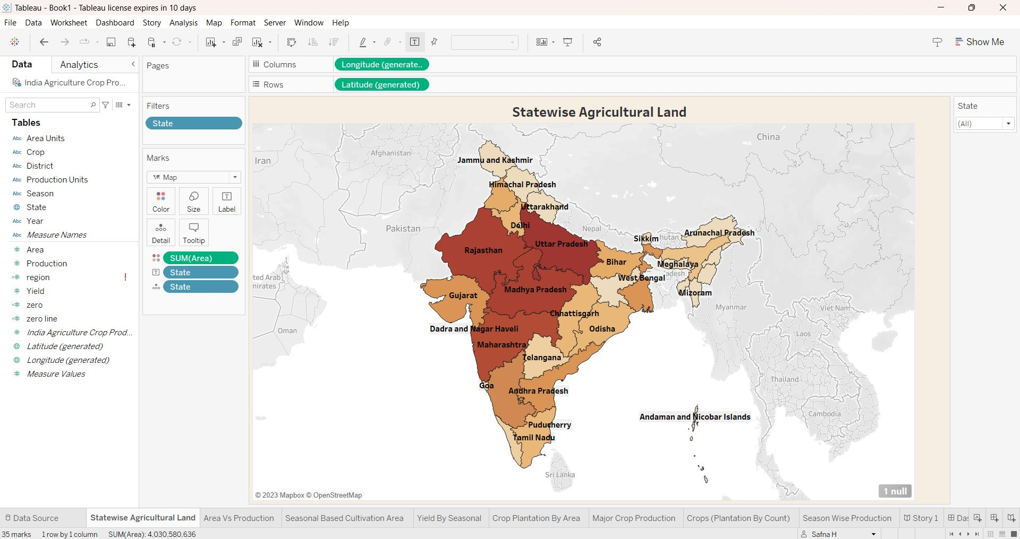

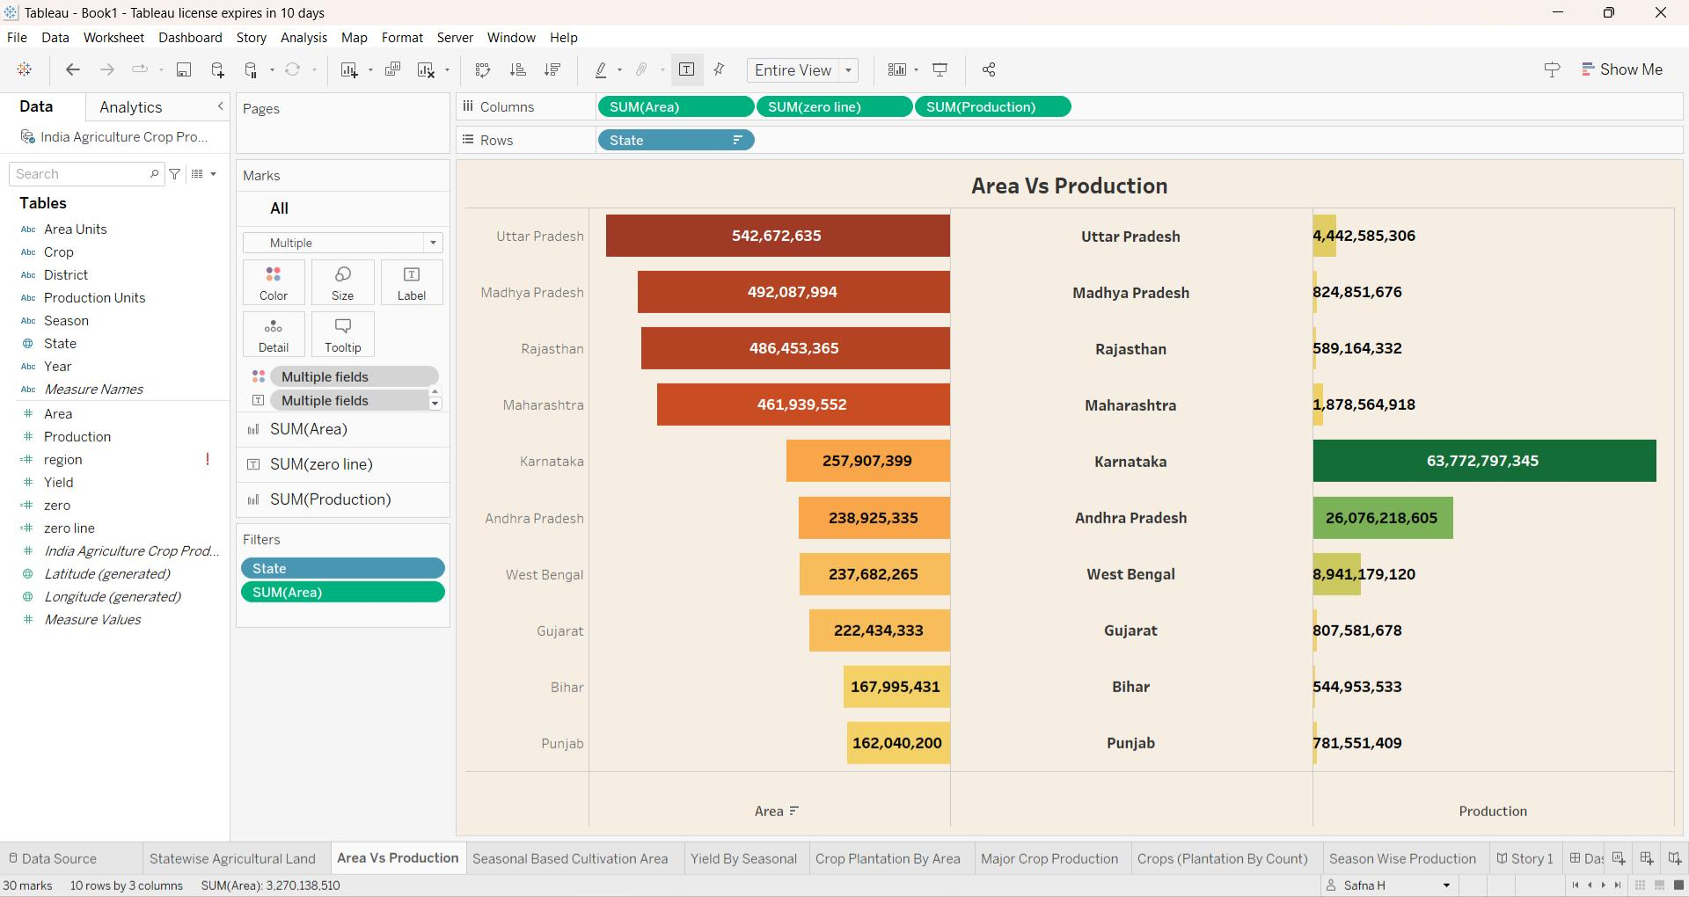

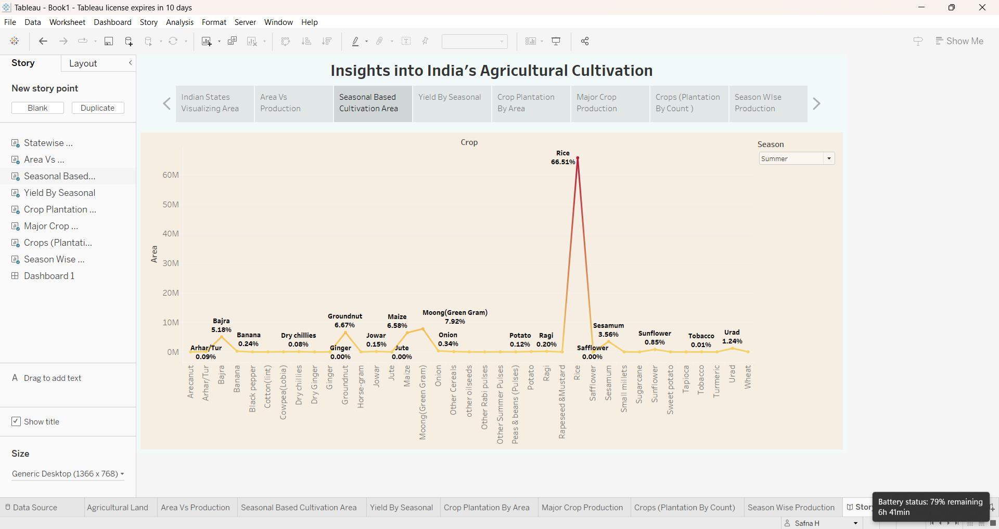

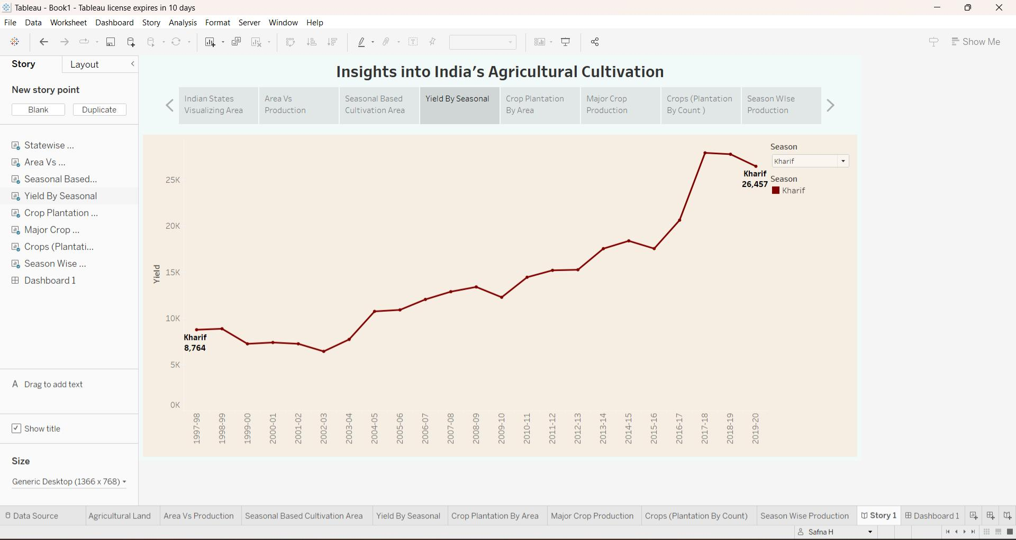

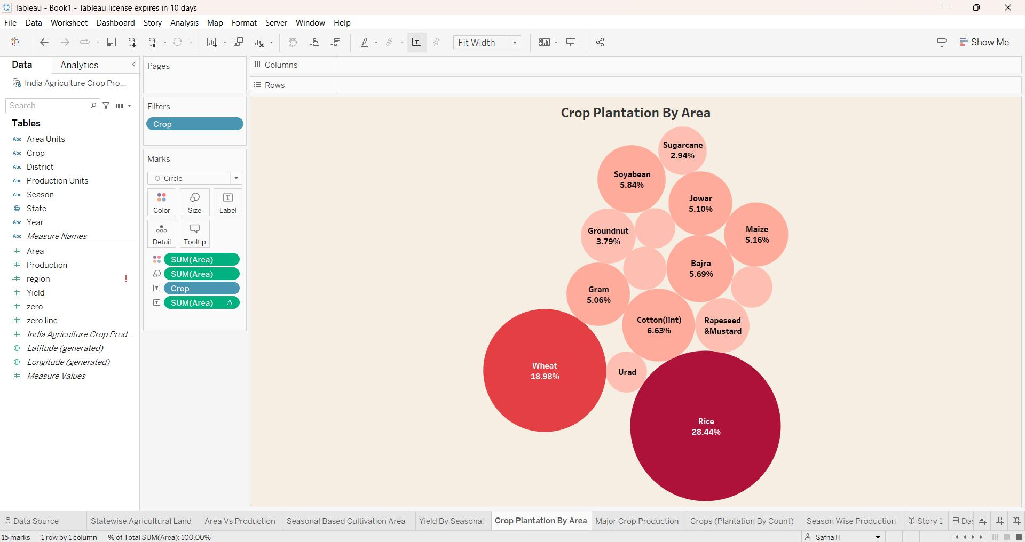

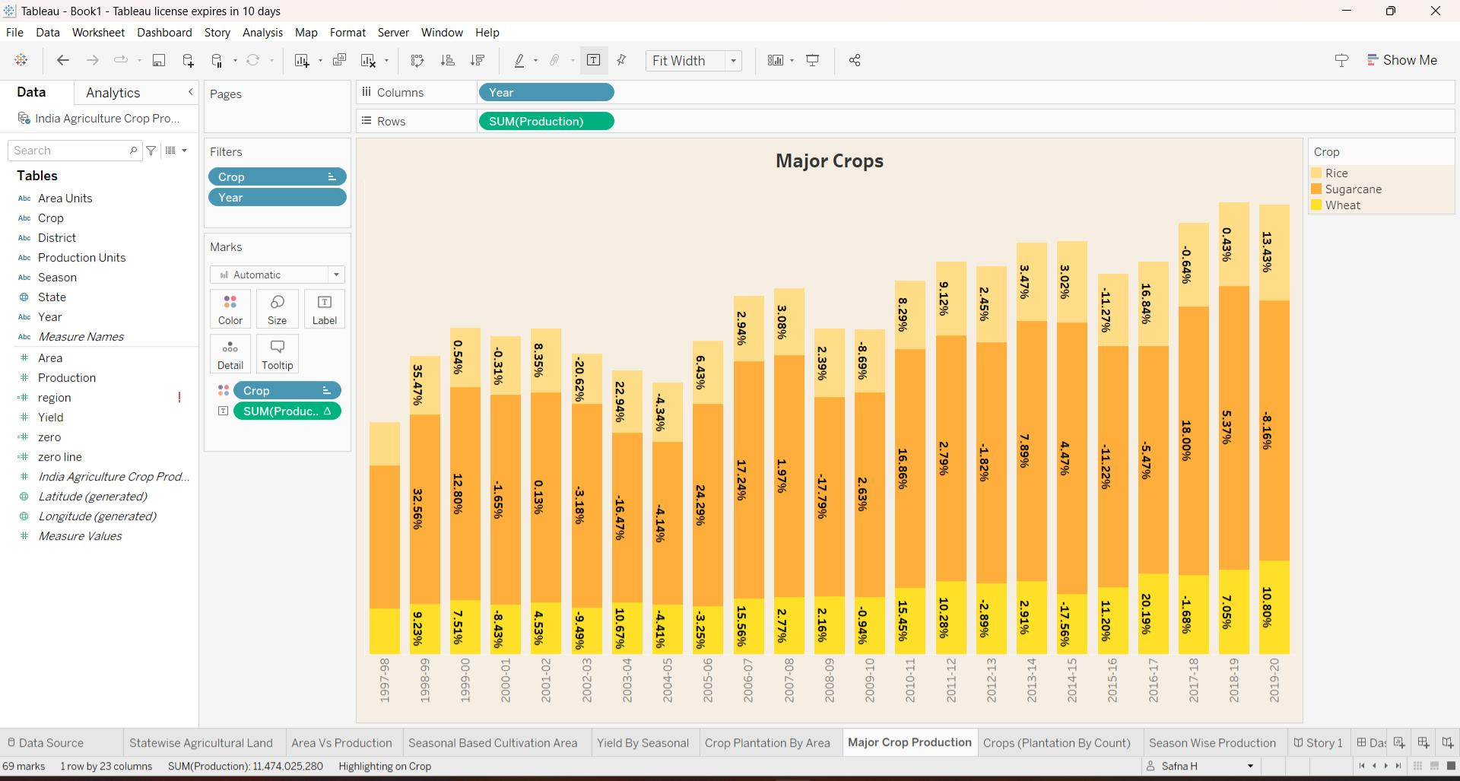

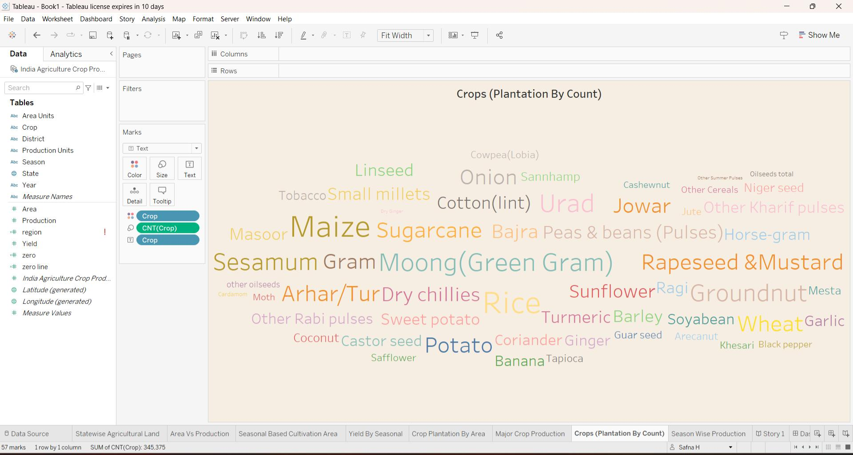

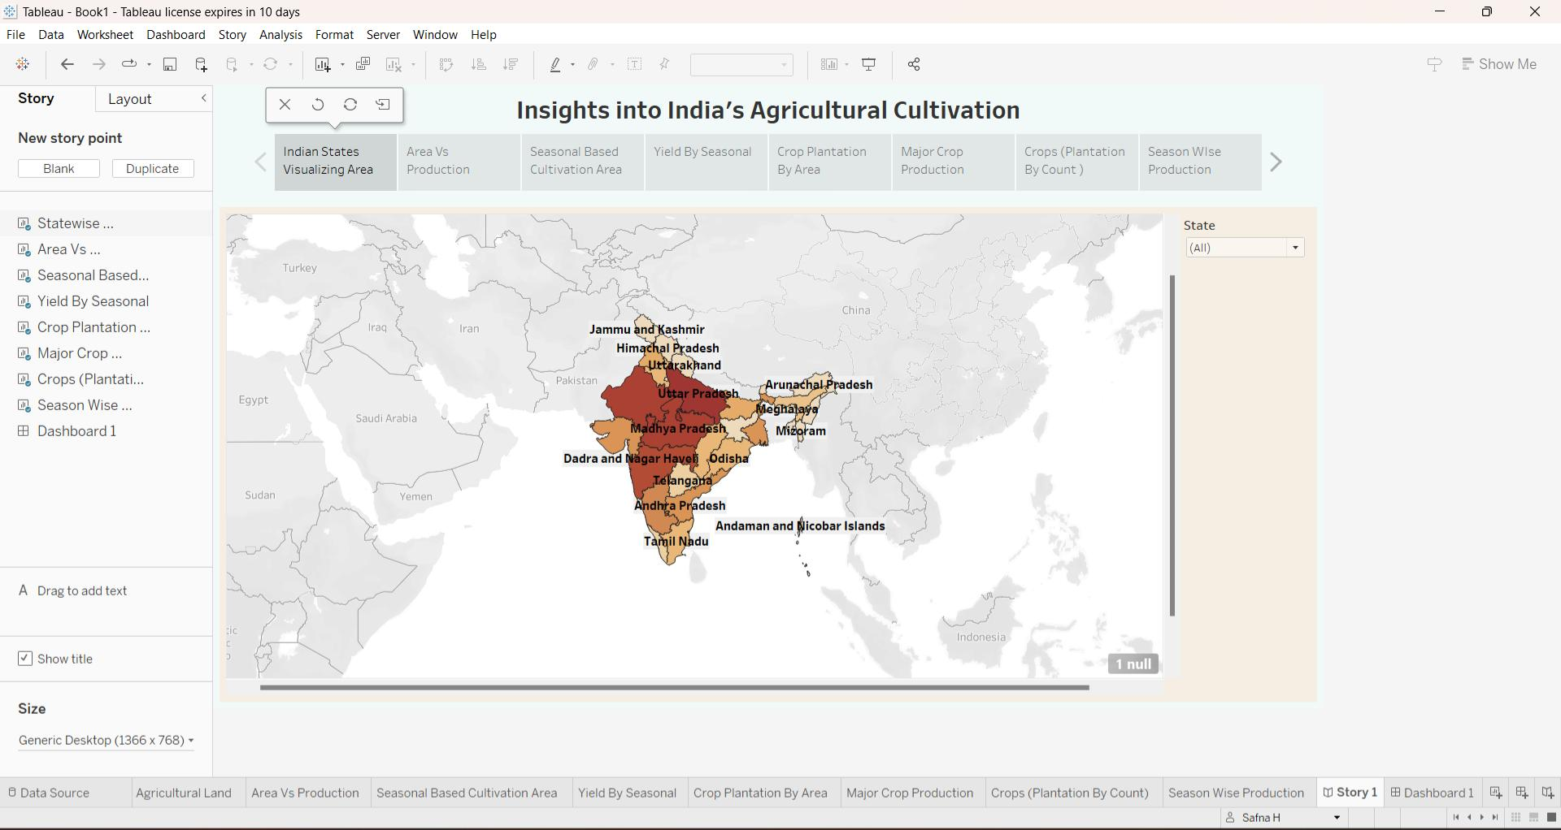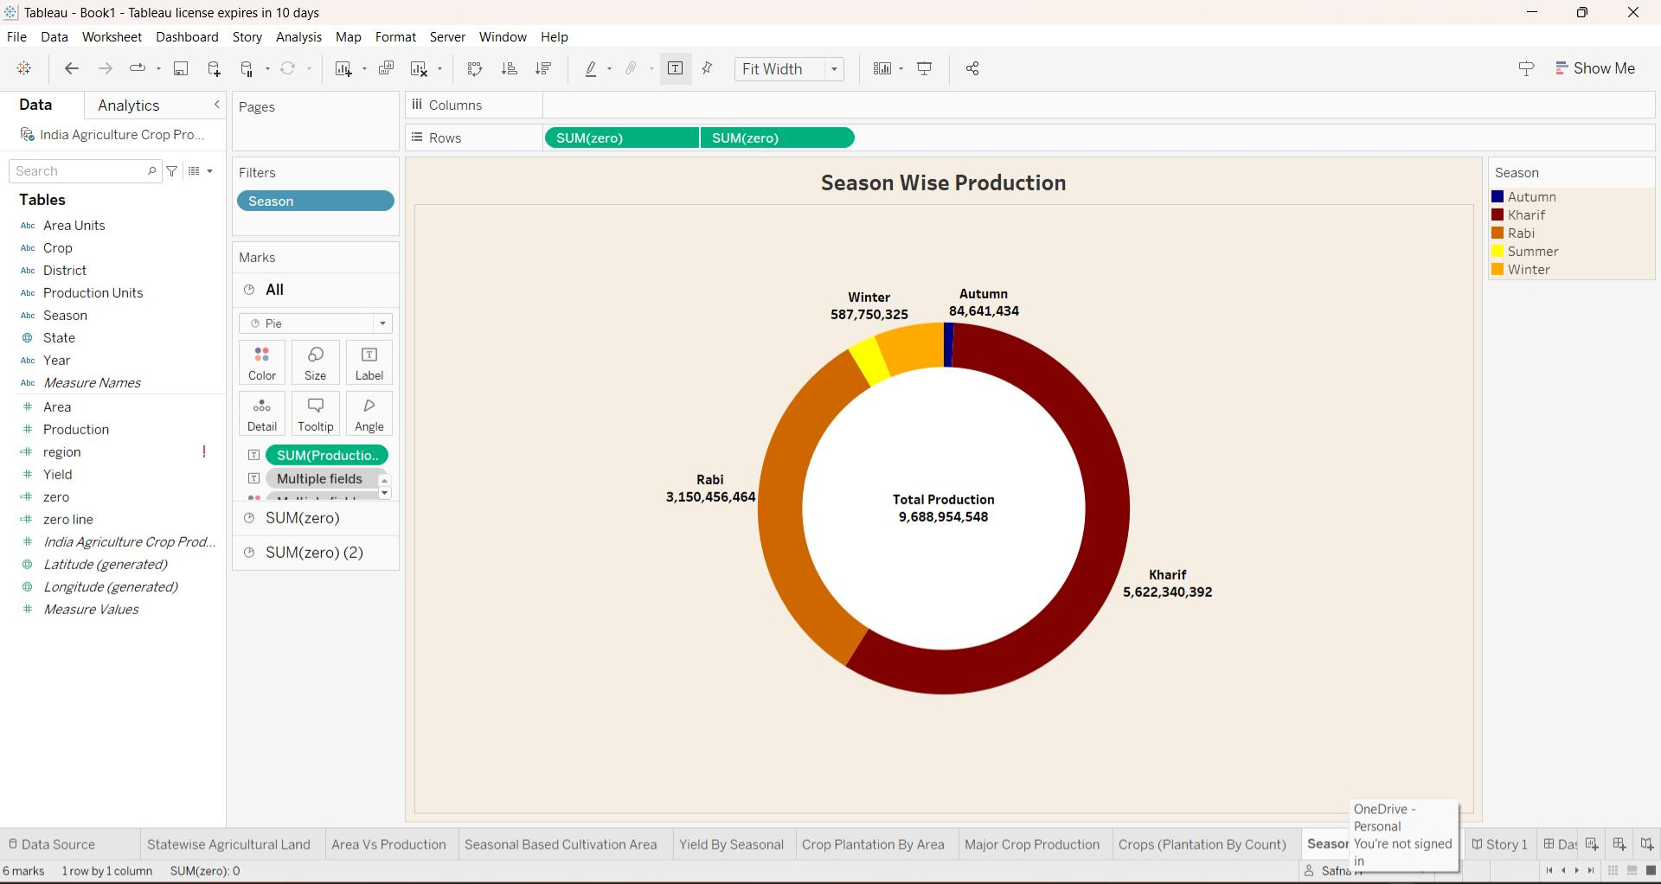

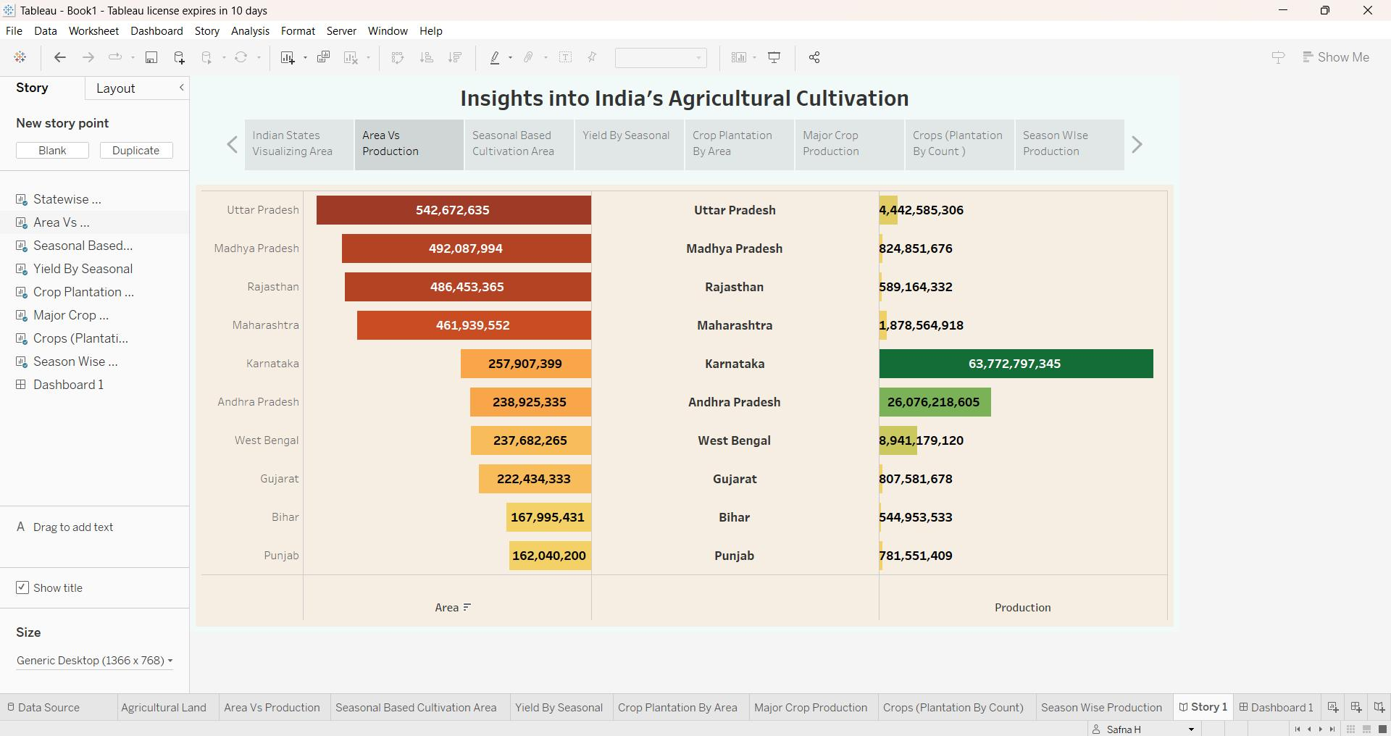

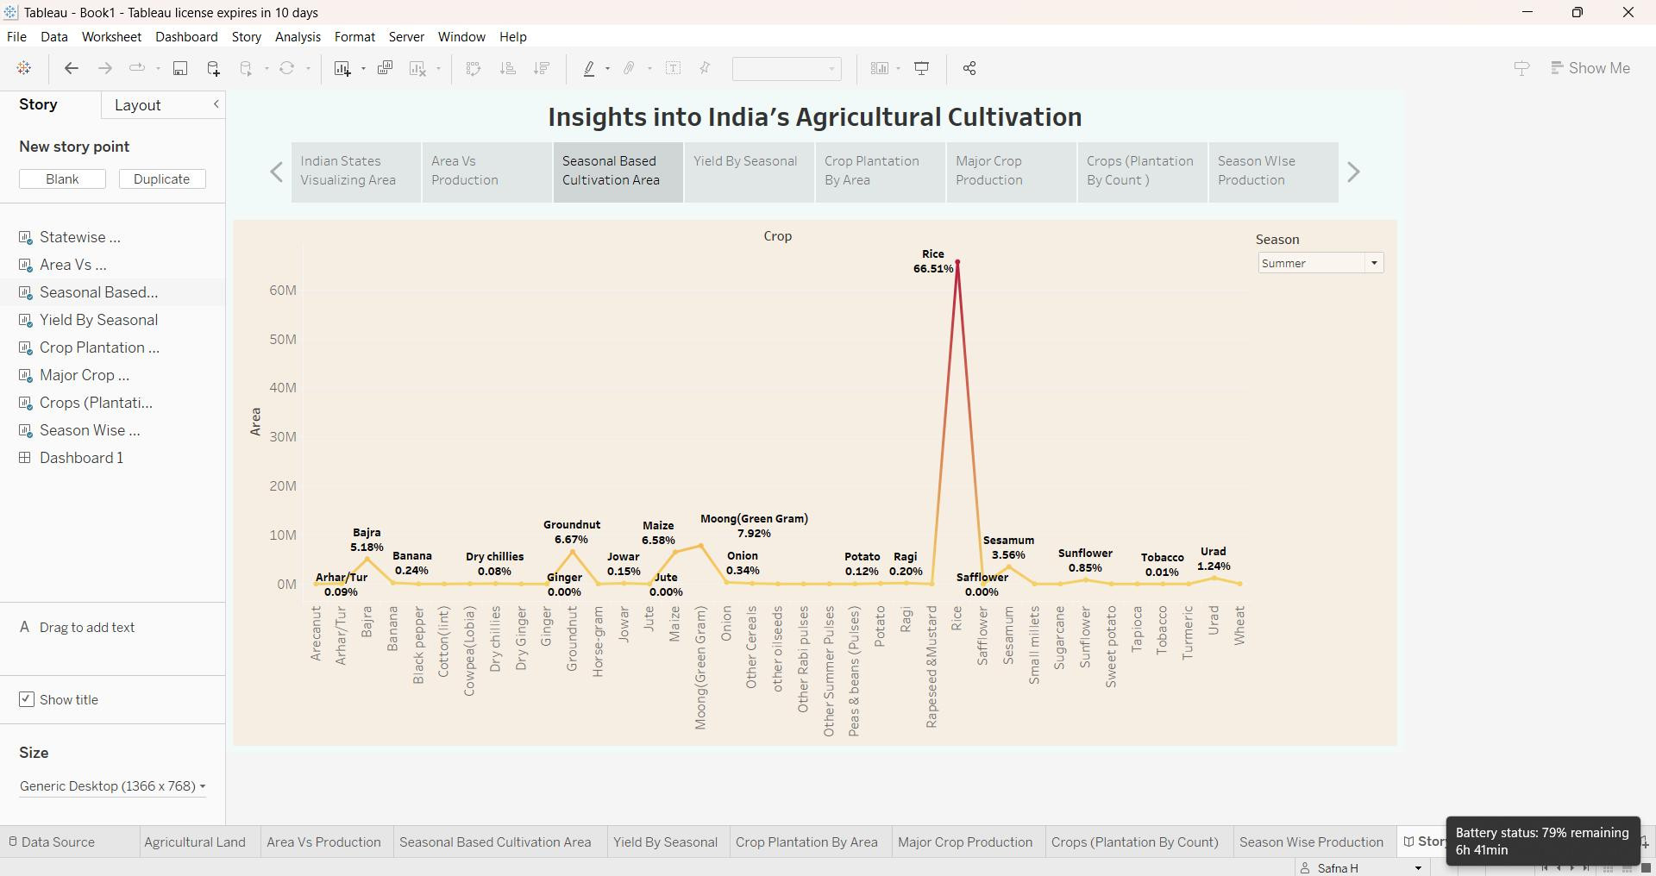

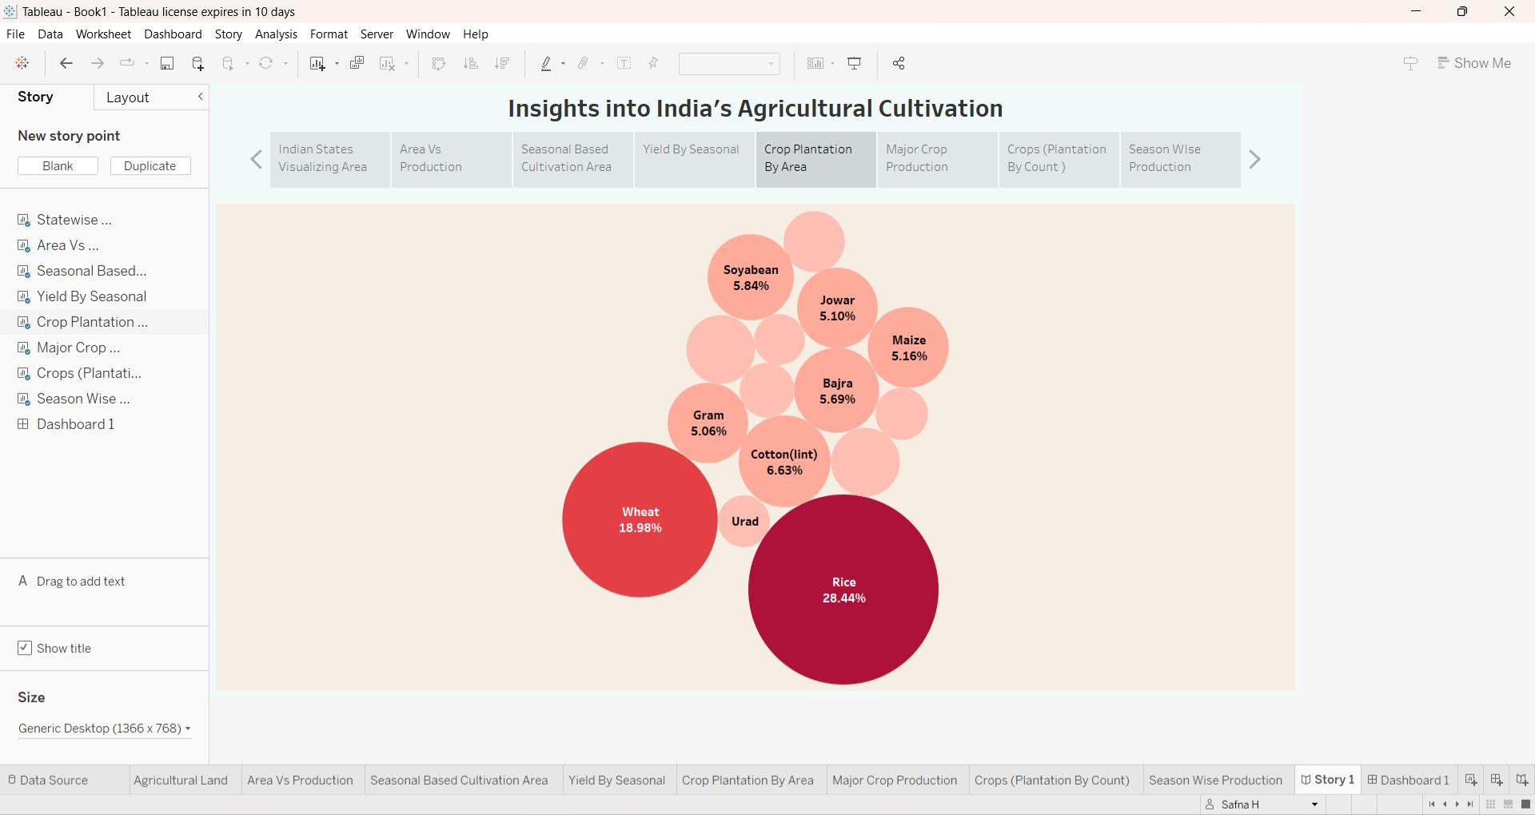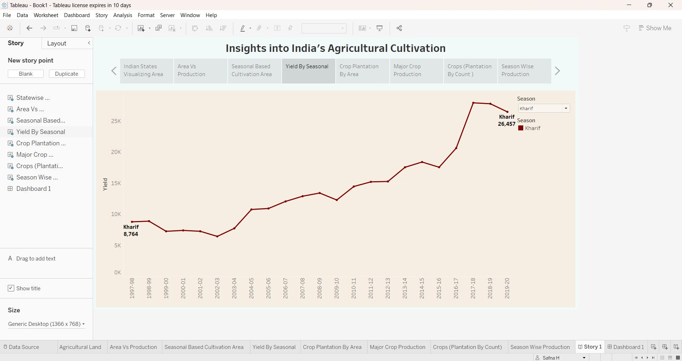

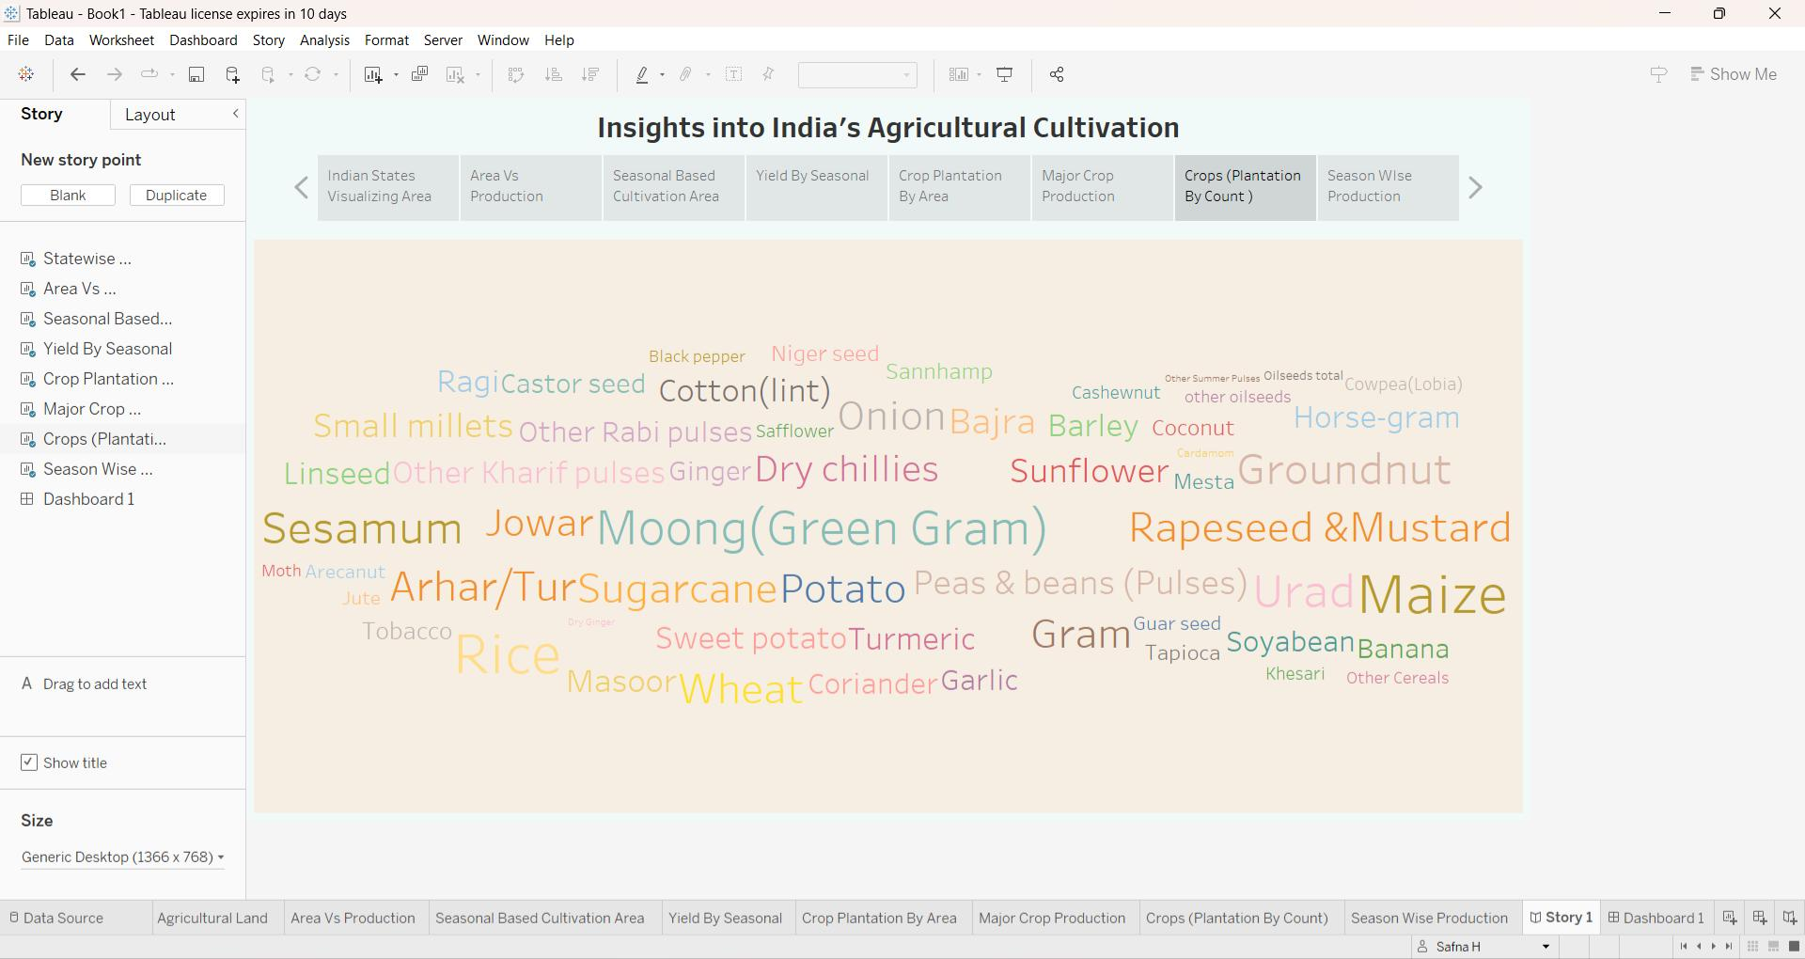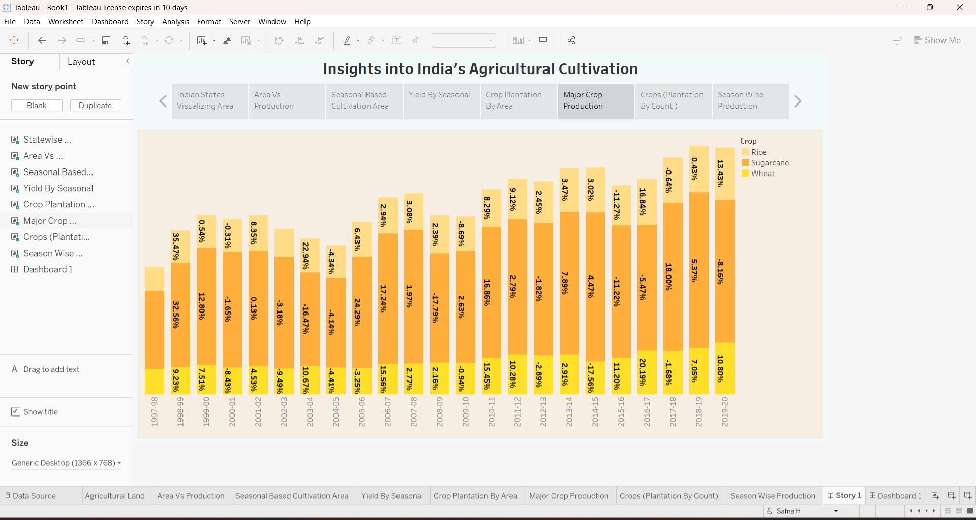

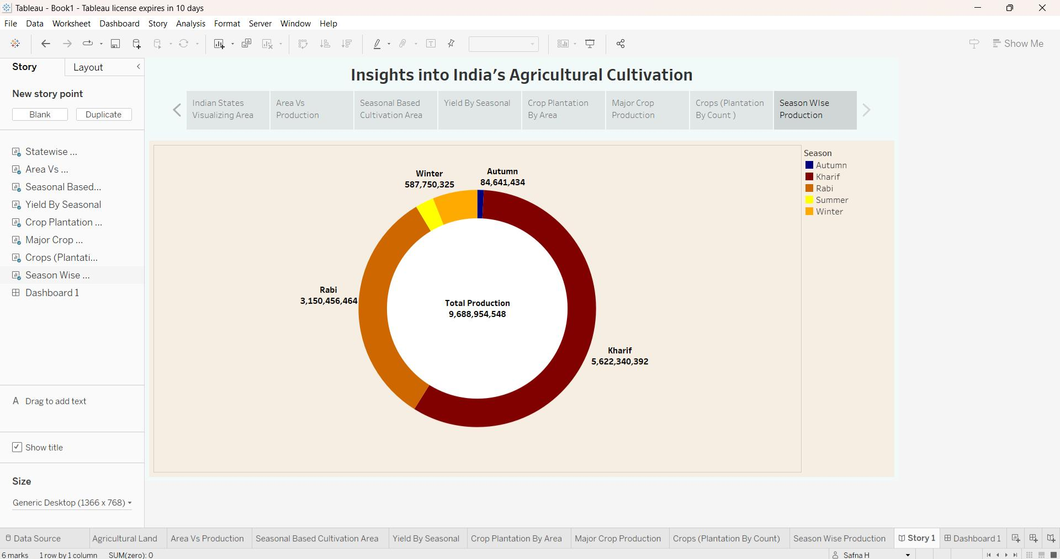

**ADVANTAGES AND DISADVANTAGES :**

**ADVANTAGES :**

**Diverse Agro climatic zones :**

India has a wide range of agro – climatic zones, allowing for the cultivation of a variety of crops throughout the year.

**Large Work force :**

India’s vast population provides a significant labor force for agricultural activities.

**Crop Diversity:**

The country grows a wide range of crops, including rice, wheat, sugarcane, cotton, and various fruits and vegetables.

**Export Opportunities :**

India can export agricultural products to international markets, contributing to its economy.

**Traditional farming :**

Many Indian farmers follow sustainable and traditional farming practices.

**DISADVANTAGES :**

**Dependency on monsoons :**

Agriculture in India is heavily dependent on monsoon rains, which can lead to crop failures during droughts or excessive rainfall.

**Land Fragmentation :**

Small landholdings are common in India, leading to inefficiencies in farming and limited mechanization.

**Post- harvest losses :**

Inadequate infrastructure and storage facilities result in significant post- harvest losses

**Lack of Technology adoption :**

Many farmers still use outdated farming techniques and have limited access to modern agricultural technology.

**Pesticides and fertilizer Overuse :**

Excessive use of pesticides and fertilizer can harm the environment and human health.

**APPLICATIONS :-**

**Food security:**

Crop production in India primarily serves as a source of food for its large and diverse population. Crops like rice, wheat, pulses, and vegetables are essential for meeting the dietary needs of the people.

**Raw materials for Food Processing :**

Many crops, like sugarcane and oilseeds, are processed to produce sugar, cooking oil, and other food products.

**Export :**

India exports a variety of agricultural products, including rice, spices, tea, coffee, and cotton. These exports contribute to foreign exchange earnings.

**Textile Industry :**

Cotton is a major crop used in the textile industry. India is one of the world’s largest producers and exporters of cotton and textile products.

**Rural development :**

Agricultural crop production can contribute to overall rural development by generating income and improving living standards in rural areas.

**Biodiversity Conservation :**

Some traditional crop varieties in India have cultural and ecological significance and are conserved to maintain biodiversity.

**Seed Production :**

India produces a substantial amount of crop seeds for both domestic consumption and export, supporting global food security.

**CONCLUSION :**

By these visualization we can obtain the solution for crop production with respect to areas, crops, seasons, cultivation etc ….

This visualization clearly defines the number of crop production in their areas with different fields.

**FUTURE SCOPE :**

Analyzing crop production data from 1997-2021 in Indian agriculture can provide valuable insights for future planning. Here are future scopes :

Sustainable practices, Agri – tech innovation, data accessibility, Predictive Modeling, Precision Agriculture, Climate Change Resilience, and Crop Diversification.

These initiatives can help Indian agriculture adapt to changing conditions and improve overall crop production in the future.

**APPENDIX :**